

**FINOLEX ACADEMY OF MANAGEMENT AND TECHNOLOGY, RATNAGIRI**

**This is to certify that the project report titled:**

## Pet Shop Management System

**Submitted By:**

Mr. Nitant Naresh Deulkar

Mr. Om Rajesh Awasare

Mr. Chandan Bhagwan Howale

**In partial fulfillment of the award for degree of**

# MASTER OF COMPUTER APPLICATION

**From Mumbai University**

## And is the bonafide record of the work done by

## them during the Semester I of A.Y 2023-2024

**Internal Guide HOD**

**(Prof. Kishor Bhosale) (Prof. Tejas V. Joshi)**



**A PROJECT REPORT ON**

## Pet Shop Management System

**Submitted in partial fulfillment for Degree of**

**MASTER OF COMPUTER APPLICATION**

**By**

Mr. Nitant Naresh Deulkar

Mr. Om Rajesh Awasare

Mr. Chandan Bhagwan Howale

**Under the guidance of**

**Prof. Kishor Bhosale**

**(Department of MCA)**

**Submitted to**

**Department of MCA**

**FINOLEX ACADEMY OF MANAGEMENT AND**

# TECHNOLOGY, RATNAGIRI

**ABSTRACT**

The "Pet Shop Management System" project is a dynamic Java standalone application aimed at revolutionizing pet shop operations. This project involves the creation of an intuitive and user-friendly software solution for managing inventory, sales, and customer interactions in pet shops. Through meticulous planning and innovative development methodologies, the project focuses on bridging the gap between pet shop owners and customers seeking high-quality pets and pet products.

The standalone application integrates advanced functionalities for enhanced user experience, including seamless transaction processing, inventory management, and a user-friendly interface for customers. This abstract encapsulates the essence of a comprehensive project that addresses the specific needs of the pet industry, setting a benchmark for user-centric digital solutions. The project's success is a testament to technical expertise, strategic planning, and dedication to delivering excellence in pet shop management.

**ACKNOWLEDGEMENT**

It gives us immense pleasure to present the report of our project here. It has been quite an experience, facing several problems at stages and coming up with appropriate solutions, at times the discussion amongst us or suggestions from our friends and teachers.

We thank our guide Prof. Kishor Bhosale, Department of Master of Computer Application, in the best possible way. Without her guidance, it wouldn’t have been possible to reach this stage. We are very grateful for his support and motivation.

We express our gratitude to Prof. Tejas V. Joshi, Professor and Head of the Department, Master of Computer Application for his invaluable suggestions and constant encouragement.

Lastly, we would like to put our thanks on record to the teaching and non-teaching staff for rendering their support directly or indirectly.

## BUSINESS CASE

1. Executive Summary:

The Pet Shop Management System is a Java standalone application aimed at streamlining pet shop operations. This project involves the development of a user-friendly software solution to manage inventory, sales, and customer interactions efficiently. The system addresses the challenges of manual record-keeping in pet shops, offering a digital platform for seamless exploration, selection, and purchase of pets and related products. This initiative supports the enhancement of pet shop management and customer experience in the ever-evolving pet industry.

2. Introduction:

The Pet Shop Management System project presents a compelling business case for the development of a Java standalone application. The intention is to create a digital platform that simplifies pet-related transactions. This system aims to offer a diverse range of pet products, serving as a centralized hub for pet enthusiasts and owners. By streamlining pet shop operations through digitalization, the project aligns with the goal of providing a comprehensive and user-friendly solution for managing inventory, sales, and customer interactions in the pet industry.

3. Statement of the Problem:

Pet shops face a challenge due to the lack of a dedicated online platform, limiting customer access to diverse pet products. The manual processes hinder efficient management and hinder the pet industry's adaptation to digital trends. The Pet Shop Management System, a standalone Java application, aims to address this problem by providing a user-friendly solution for managing inventory and enhancing the overall customer experience.

4. Analysis:

To tackle the identified problem, a comprehensive analysis has been conducted for the Pet Shop Management System. This analysis considers market trends, customer preferences, and strategic objectives. Market research reveals an increasing demand for dedicated online platforms in the pet industry. The absence of such a system can potentially impact the pet shop's revenue and market position. The standalone Java application aims to address this gap by aligning with market trends, fulfilling customer preferences, and supporting the organization's strategic goals in the pet industry.

5. Discussion of Possible Options:

Benefits:

Market Expansion: The Pet Shop Management System's development as a Java standalone application offers the opportunity to tap into the expanding e-commerce market for pet-related products, reaching a wider audience and increasing market presence.

Brand Visibility: The standalone application acts as an additional touchpoint for pet shop customers, enhancing brand visibility. It has the potential to attract new customers who appreciate the convenience of managing pet-related transactions online, thereby strengthening the brand's overall presence in the pet industry.

Costs:

Development Costs: Initial investment for Java standalone application development, covering platform design and e-commerce functionality.

Maintenance Expenses: Ongoing costs for regular updates and technical support to ensure optimal performance of the Pet Shop Management System.

Time-scale:

Development Time: Six-month timeline for Pet Shop Management System development, ensuring a seamless user experience with thorough testing.

Return on Investment: Anticipate ROI within the first year as the standalone Java application gains traction and boosts customer engagement in the pet industry.

Risks:

Competition: Risk of market share competition in the online pet industry.

Technical Challenges: Potential technical glitches or delays during Java standalone system development may impact the project timeline.

6. Recommendation:

Proceed with developing the Pet Shop Management System as a Java standalone application (Option 1). Despite initial costs and potential risks, the long-term benefits in revenue generation and market positioning outweigh the drawbacks. This aligns with the goal of enhancing pet inventory management and customer experience in the pet industry.

## TABLE OF CONTENT

|  |  |  |
| --- | --- | --- |
| Sr no | Content | Page No |
| **1.** | **Introduction** | 10 |
|  | 1.1 Background | 10 |
|  | 1.2 Objectives | 10 |
|  | 1.3 Purpose, Scope and Applicability | 11 |
| **2.** | **Survey Of Technologies** | 12 |
|  | 2.1 Existing Systems and its Limitations | 12 |
|  | 2.2 Proposed System | 12 |
| **3.** | **Requirements and Analysis** | 14 |
|  | 3.1 Problem Definition | 14 |
|  | 3.2 Requirement Specifications | 14 |
|  | 3.3 Planning and Scheduling – Gantt Chart | 15 |

|  |  |  |
| --- | --- | --- |
|  | 3.4 Software Requirements | 16 |
|  | 3.5 Hardware Requirements | 16 |
|  | 3.6 UML Diagrams | 16 |
| **4.** | System Design | 20 |
|  | 4.1 System Architecture and Modules | 20 |
|  | 4.2 Data Design | 21 |
|  | 4.3 User Interface Design | 23 |
|  | 4.4 Test Case Design | 27 |
| **5.** | Conclusion | 29 |
| **6.** | Bibliography | 30 |

**TABLE OF FIGURES**

|  |  |  |  |
| --- | --- | --- | --- |
| **Sr. No.** |  | **Figures** | **Page No.** |
| 1. | Fig 1: Planned Gantt Chart |  | 15 |
| 2. | Fig 2: ER Diagram |  | 16 |
| 3. | Fig 3: Use Case Diagram |  | 17 |
| 4. | Fig 4: Class Diagram |  | 17 |
| 5. | Fig 5: Sequence Diagram |  | 18 |
| 6. | Fig 6: Deployment Diagram |  | 18 |
| 7. | Fig 7: Activity Diagram |  | 19 |
| 8. | Fig 8: Splash Screen |  | 23 |
| 9. | Fig 9: Employee Login Page |  | 23 |
| 10. | Fig 10: Admin Login Page |  | 24 |
| 11. | Fig 11: Users Page |  | 24 |
| 12. | Fig 12: Pets Page |  | 25 |
| 13. | Fig 13: Category Page |  | 25 |
| 14. | Fig 14: Customer Page |  | 26 |
| 15. | Fig 15: Billing Page |  | 26 |

## INTRODUCTION

**1.1 Background**

The "Pet Shop Management System" is a straightforward Java standalone application tailored for the efficient management of offline pet shops. This project serves as a practical system for overseeing various aspects of a pet shop, offering a user-friendly solution for both individuals and businesses involved in pet retail.

The system streamlines the process of managing and ordering pet inventory, ensuring that products are readily available. With features designed for simplicity, this system becomes a valuable tool for enhancing the operational efficiency of pet shops. It provides a user-friendly online platform that simplifies the tasks of finding, purchasing, and managing high-quality pets and pet products. The implementation of this system aims to bring about improvements in the organization's quality and transparency, offering a streamlined approach to offline pet shop management.

**1.2 Objective**

The objective of the Pet Shop Management System, a Java standalone application for managing offline pet shops, is to provide a convenient and efficient platform for customers to access and obtain a wide range of pets and pet-related products.

The system aims to simplify the process of finding and purchasing specific pets and products, catering to various breeds and categories. It strives to offer a diverse inventory, ensuring customers can easily locate the right pets and accessories without the need to visit physical stores.

The system's primary focus is to streamline the ordering process, allowing customers to search for pets and products, add them to their cart, and complete the transaction with minimal effort. Competitive pricing, promotions, and discounts are integrated to ensure customers receive good value for their purchases. Additionally, the system provides multiple channels for customer assistance, including phone support, email, and live chat, enhancing the overall customer experience in managing offline pet shops.

**1.3 Purpose, Scope, Applicability**

1.3.1 Purpose

The purpose of the "Pet Shop Management System," a Java standalone application, is to provide a streamlined platform for managing offline pet shops. It simplifies the process of exploring, selecting, and purchasing pets and pet-related products, offering a user-friendly experience for both pet shop owners and customers. The system aims to enhance overall pet shop management.

1.3.2 Scope:

The "Pet Shop Management System" is a standalone Java application that serves as a digital platform for pet shop owners and individual pet owners alike.

This system allows users to efficiently manage various aspects of pet shop operations, providing features such as pet inventory management, and customer engagement. Pet shop owners can easily add, update, and delete pet information, generate invoices, and communicate effectively with customers.

The application ensures a user-friendly experience, facilitating seamless interaction with the system's modules. It is designed to enhance the overall management of pet-related products and services within the offline pet shop environment.

This project is about Pet Shop Management application and will consist of some modules

1. Splash Screen Module
2. Login Module
3. Pets Management Module
4. Customer Management Module
5. Users Management Module
6. Category Management Module
7. Billing Module
8. Logout Module
9. Database Integration

1.3.3 Applicability

The Pet Shop Management System, as a standalone Java application, is designed to cater to various users, including:

* Pet Shop Owners: Individuals managing and owning pet shops, benefiting from streamlined pet inventory management, customer engagement, and efficient billing processes.
* Service Providers: Companies offering logistics and delivery services specifically tailored for the pet industry.

## 2. SURVEY OF TECHNOLOGIES

2.1 Existing System and its limitations:

The current scenario in the pet industry, particularly for purchasing and managing pet-related products, often relies on traditional methods such as brick-and-mortar pet shops or generic e-commerce platforms. However, these approaches come with inherent limitations:

* Limited Accessibility:

Pet owners may encounter challenges accessing a diverse range of pet products, depending on the availability of local pet shops. This limitation restricts their choices and may not cater to specific pet care needs.

* Inconvenient Purchase Process:

Traditional purchasing methods, requiring physical visits to pet shops, can be inconvenient for pet owners with busy schedules or those residing in remote areas. This may lead to a less-than-optimal shopping experience.

* Uncertain Product Information:

Customers may face difficulties in obtaining comprehensive information about pet products, including specifications, compatibility, and customer reviews. This lack of detailed information can result in dissatisfaction after the purchase.

* Delivery Delays:

Inconsistencies in the delivery process may lead to delays in receiving ordered pet products, causing frustration among customers eagerly awaiting their purchases.

2.2 Proposed System and its Advantages:

The envisioned "Pet Shop Management System" aims to overcome the limitations of existing pet industry management by introducing a specialized standalone Java application tailored for pet shops and pet enthusiasts. The proposed system offers several advantages to enhance the overall experience:

* Comprehensive Product Catalog: The system provides a diverse catalog of pet-related products, offering a wide array of choices that may not be readily available in local pet shops.
* Convenient Management: Pet shop owners and employees can efficiently manage pet inventory, customer information, and billing through the convenience of a standalone Java application, eliminating the need for traditional manual methods.
* Detailed Product Information: The application ensures comprehensive information about pets and pet products, including details such as pet characteristics, availability, and customer reviews, empowering users to make informed decisions.
* Efficient Order Processing: Implementation of a robust order processing system ensures timely delivery of pet products to customers, contributing to enhanced customer satisfaction.
* User-Friendly Interface: The system features a user-friendly interface, facilitating easy navigation, product searches, and seamless transactions, making it accessible to pet shop owners with varying levels of technical expertise.
* Personalized User Accounts: Pet shop owners and employees can create accounts to track pet inventory, manage customer information, and utilize personalized features, enhancing the overall user experience and operational efficiency.

### 3. REQUIREMENTS AND ANALYSIS

3.1 Problem Definition

The core issue addressed by the "Pet Shop Management System" project is the inefficiency and limitations inherent in the current manual management of pet shops. Challenges include difficulties in managing pet inventory, customer information, and billing using traditional methods. These challenges often lead to a less-than-optimal shopping experience for pet owners and may hinder the smooth operation of pet shops. The goal of this project is to overcome these challenges by developing a standalone Java application that offers a specialized platform. The system aims to streamline pet shop management processes, providing a user-friendly interface for pet shop owners to efficiently manage inventory, customer interactions, and billing.

3.2 Requirements Specification

The requirements for the project can be categorized into functional and non-functional requirements:

Functional Requirements:

* User Registration and Authentication:

Enable pet shop owners and employees to create accounts, log in securely, and manage their profiles within the standalone offline Java application.

* Pets Catalog Management:

Support offline addition, modification, and removal of pets in the catalog.

Include details such as images, descriptions, and prices for each pet, accessible without an internet connection.

* Functionality:

Implement secure offline payment gateways to support transactions within the pet shop.

Allow users to add pets to a virtual shopping cart, review selections, and proceed to checkout without requiring an internet connection.

* Order Management:

Provide real-time order tracking for pet shop owners and employees.

Enable order confirmation and delivery status notifications to be managed offline within the pet shop.

* User Feedback and Review System:

Implement an offline system for pet shop users to leave feedback and reviews for pets.

Display average ratings and reviews on pet pages, all accessible without an internet connection.

* Search and Filter Options:

Include a robust offline search engine and filtering options to help pet shop owners and employees find specific pets efficiently within the standalone application.

Non-functional Requirements:

* Security: Implement robust security measures within the standalone Java application to safeguard user data, utilizing encryption for sensitive information.
* Scalability: Design the system to be scalable, capable of accommodating a growing number of users, pets, and products over time.
* Performance: Strive for fast and responsive system performance within the offline pet shop environment, minimizing page load times to enhance user efficiency.
* User Interface (UI) Design: Design an intuitive and visually appealing user interface for the standalone Java application, prioritizing ease of navigation and providing a positive user experience.

3.3 Planning and Scheduling – Gantt chart

|  |  |  |  |  |  |  |  |  |  |  |  |  |  |  |  |  |  |  |  |  |  |  |  |  |  |  |  |  |  |  |
| --- | --- | --- | --- | --- | --- | --- | --- | --- | --- | --- | --- | --- | --- | --- | --- | --- | --- | --- | --- | --- | --- | --- | --- | --- | --- | --- | --- | --- | --- | --- |
| **Pet Shop Management System**  Axis Title  9/1/2023 9/21/2023 10/11/2023 10/31/2023 11/20/2023 12/10/2023 12/30/2023  Project Finalization and Approval  **Task**  Documentation  Database Design  Coding  Final Documentation   |  |  |  |  |  |  |  |  |  |  | | --- | --- | --- | --- | --- | --- | --- | --- | --- | --- | |  | Final  Documentat ion | Testing | Coding | ERD|UML Diagrams | Database Design | Modules Design | Documentat ion | Requiremen t gathering | Project  Finalization and  Approval | | Start date | 12/11/2023 | 12/3/2023 | 11/11/2023 | 11/1/2023 | 10/21/2023 | 10/2/2023 | 9/19/2023 | 9/6/2023 | 9/1/2023 | | Duration | 4 | 7 | 21 | 9 | 9 | 18 | 12 | 12 | 4 | |

Fig 1: Gantt Chart

3.4 **Software Requirements**:

* + - Front End/GUI Tools – Java (JFrame – Swing Framework)
    - IDE- Apache NetBeans IDE 18
    - Back End – Java
    - Server- SQL Server

3.5 **Hardware Requirements** :

* + - Processor = intel i5 10th generation
    - Ram- 8GB RAM
    - Storage- 256GB SSD

3.6 UML Diagrams

3.6.1

E

ntity

R

elationship Diagram

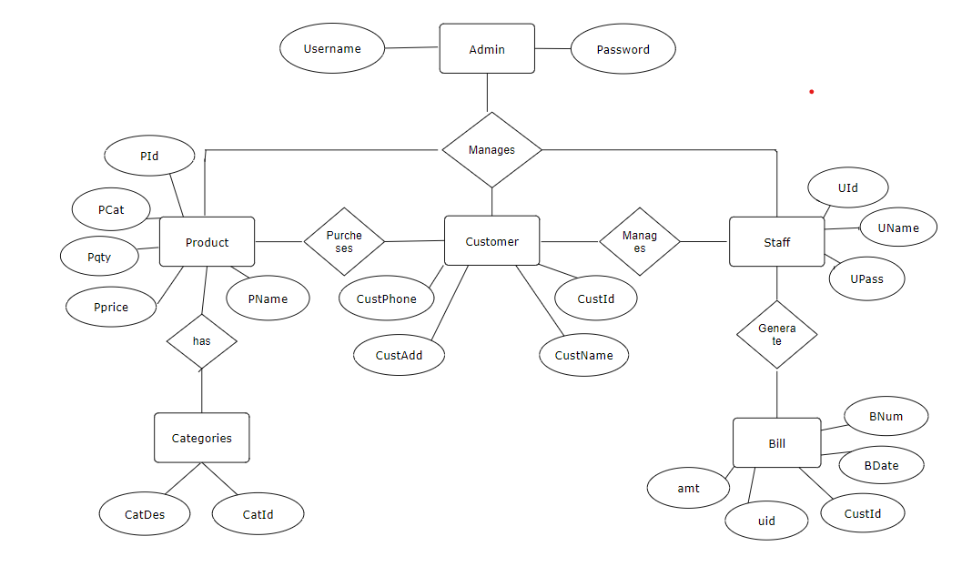

Fig 2: ER Diagram

3.6.2

Use

C

ase Diagram

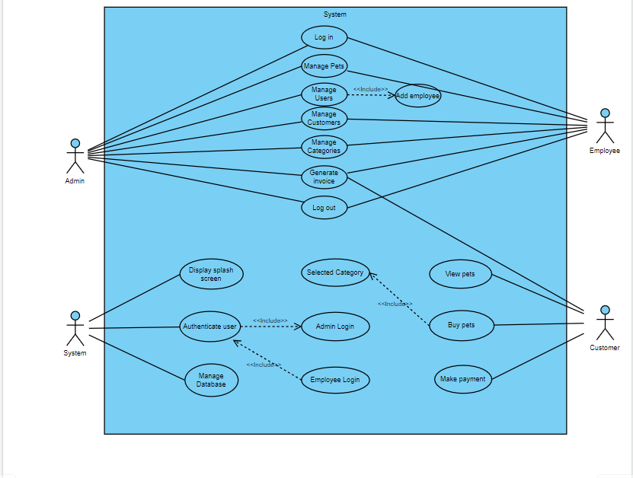

Fig 3: Use Case Diagram

3.6.3

Class Diagram

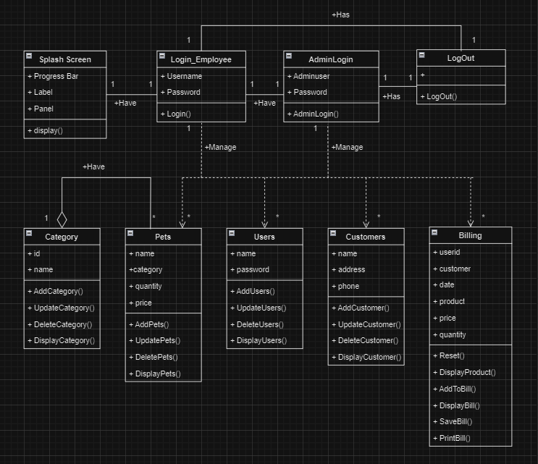

Fig 4: Class Diagram

3.6.4

Sequence Diagram:

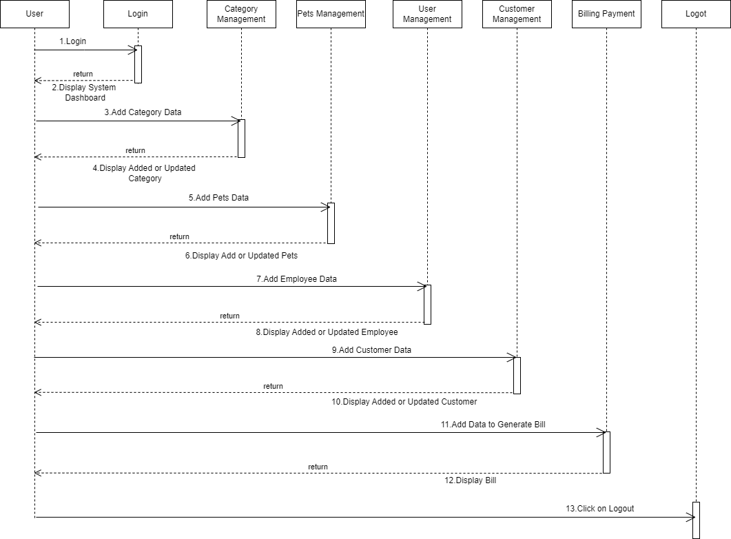

Fig 5: Sequence Diagram

3.6.5

Deployment Diagram:

Fig

6

:

Deployment Diagram

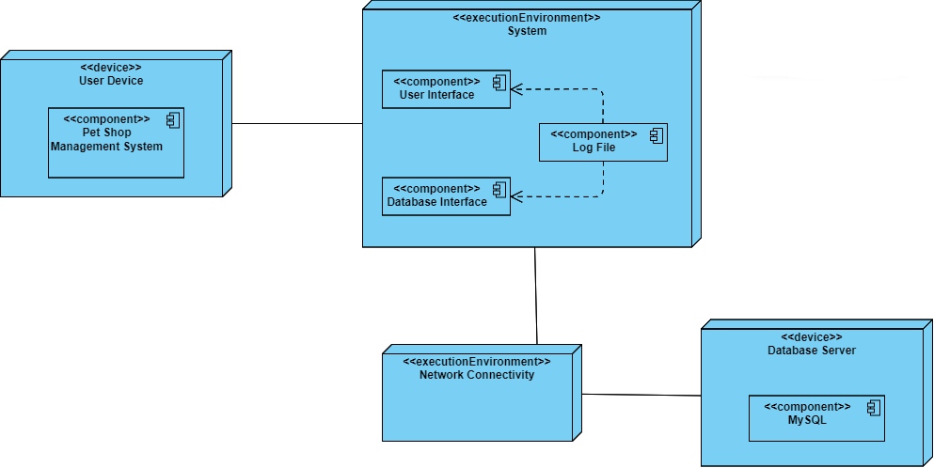

3.6.6

Activity Diagram

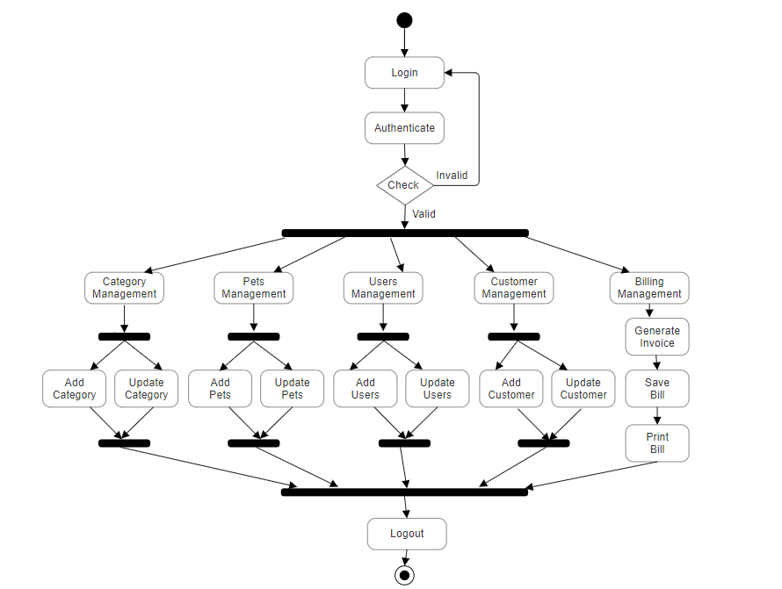

Fig 7: Activity Diagram

## 4. SYSTEM DESIGN

4.1 System Architecture:

The system will follow a three-tier architecture:

1. Presentation Tier (UI):

* Modules: Splash Screen, Login, Pets Management, Customer Management, Users Management, Category Management, Billing, Logout.
* Description: This tier represents the user interface (UI) of the standalone application. Each module is responsible for presenting information and capturing user interactions within the application window.

1. Application Tier (Business Logic):

* Modules: Pets Management, Customer Management, Users Management, Category Management, Billing.
* Description: This tier encapsulates the business logic of the application. It handles user requests, and manages interactions with the internal database. Each module in this tier contains specific business logic related to its functionality.

1. Data Tier (Database Integration):

* Module: Database Integration.
* Description: This tier corresponds to the storage and retrieval of data. The Database Integration module facilitates communication with the internal database, storing and retrieving information related to pets, customers, users, categories, and billing details.

Modules :

1. Splash Screen Module: This module provides a visually appealing loading screen that introduces users to the Pet Shop Management application. It ensures a smooth and engaging initial experience for users launching the application.
2. Login Module: The Login Module handles user authentication, allowing authorized personnel to access the application. It includes secure login interfaces for employees and administrators, ensuring data privacy.
3. Pets Management Module: Responsible for managing pet-related data, this module allows users to add, update, and delete information about pets. Fields include pet name, quantity, price, and category. A visual table displays the added or updated pet data.
4. Customer Management Module: Focused on user interactions, the Customer Management Module handles user registration, authentication, and activities related to customers. Users can browse pets, add items to the shopping cart, manage orders, and view order history.
5. Users Management Module: This module facilitates the management of user data. It includes functionalities for adding, updating, and deleting user information. It ensures the secure handling of user credentials and other relevant data.
6. Category Management Module: Responsible for organizing pet-related products, the Category Management Module allows the addition, updating, and deletion of categories (e.g., pet, food, accessories). It ensures a structured organization for the products.
7. Billing Module: The Billing Module automates the process of generating invoices for accurate and efficient financial transactions. It ensures that the billing process is streamlined and error-free.
8. Logout Module: This module provides a secure mechanism for users to log out of their current session, ensuring data privacy and system security.
9. Database Integration: The Database Integration Module is responsible for the integration with the internal database. It handles the storage and retrieval of data related to pets, users, customers, categories, billing, and other relevant information.

4.2 Data Design (Database tables and database diagram)

1. User Table:

|  |  |  |  |
| --- | --- | --- | --- |
| **Column name** | **Description** | **Type** | **Constraints** |
| Uid | Id of user | INT | PRIMARY KEY |
| Uname | Name of User | VARCHAR |  |
| Upass | Password of the user | VARCHAR |  |

1. Category Table:

|  |  |  |  |
| --- | --- | --- | --- |
| **Column name** | **Description** | **Type** | **Constraints** |
| CatId | ID of the Category | INT | PRIMARY KEY |
| CatDes | Name of the Category | VARCHAR |  |

1. Pet Table:

|  |  |  |  |
| --- | --- | --- | --- |
| **Column name** | **Description** | **Type** | **Constraints** |
| PId | ID of the pet | INT | PRIMARY KEY |
| PName | Name of the pet | VARCHAR |  |
| PCat | Category of the pet | INT | FOREIGN KEY |
| Pqty | Quantity of the pet | INT |  |
| Pprice | Price of the pet | INT |  |

1. Customer Table:

|  |  |  |  |
| --- | --- | --- | --- |
| **Column name** | **Description** | **Type** | **Constraints** |
| CusId | ID of the customer | INT | PRIMARY KEY |
| CustName | Name of the customer | VARCHAR |  |
| CustAdd | Address of the customer | VARCHAR |  |
| CustPhone | Mobile no. of customer | VARCHAR |  |

1. Bill Table:

|  |  |  |  |
| --- | --- | --- | --- |
| **Column name** | **Description** | **Type** | **Constraints** |
| BNum | Bill Number | INT | PRIMARY KEY |
| BDate | Date of bill | VARCHAR |  |
| CustId | Customer id | INT | FOREIGN KEY |
| uid | User id | INT | FOREIGN KEY |
| amt | Total amount | INT |  |

4..3 User Interface Design

1

. Splash Screen

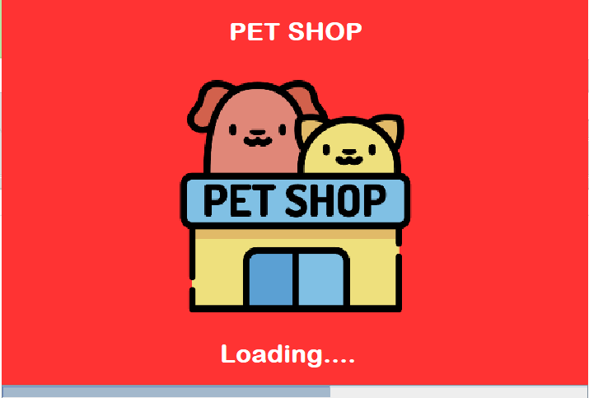

Fig 8: Splash Screen

2

. Employee Login Page

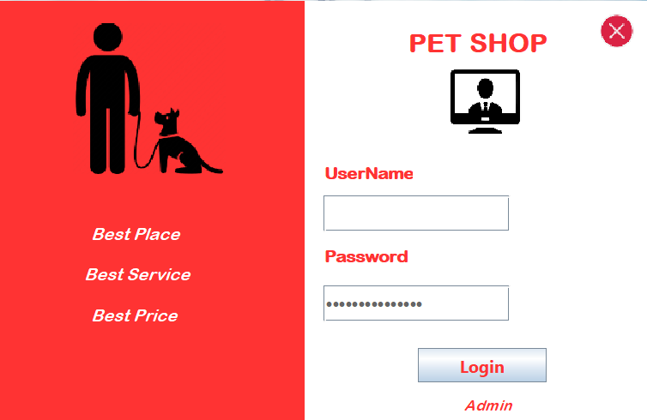

Fig 9: Employee Login Page

3

. Admin Login Page

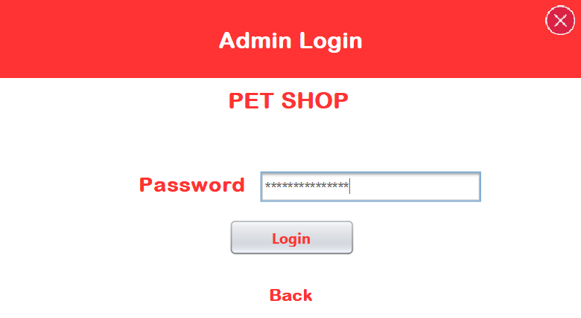

Fig 10: Admin Login Page

4

. Users Page

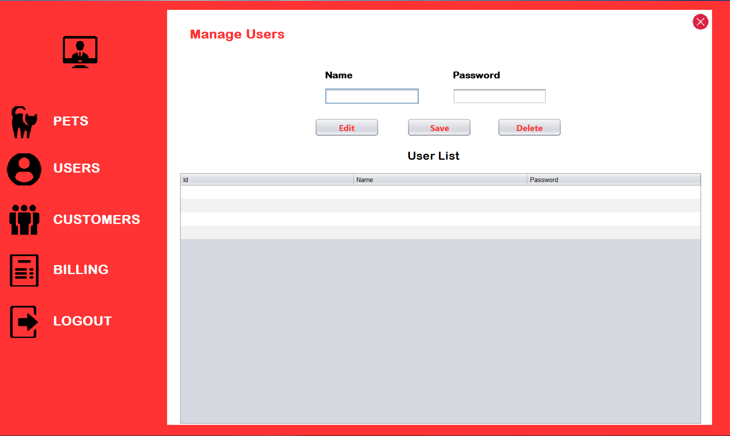

Fig 11: Users Page

5

. Pets Page

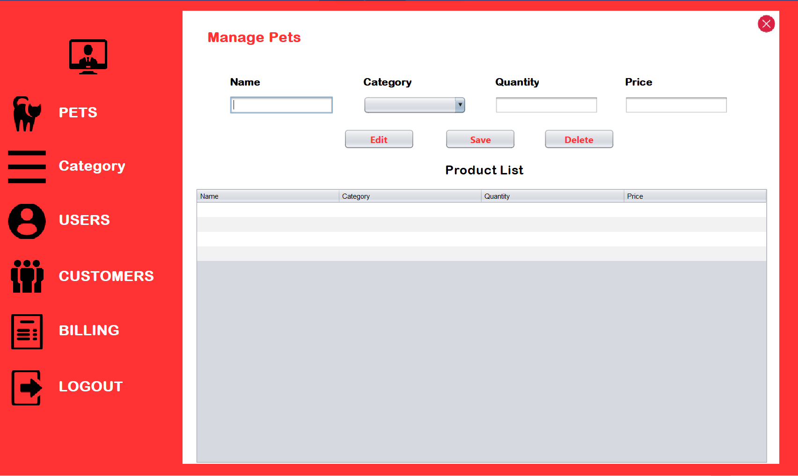

Fig 12: Pets Page

6

. Category Page

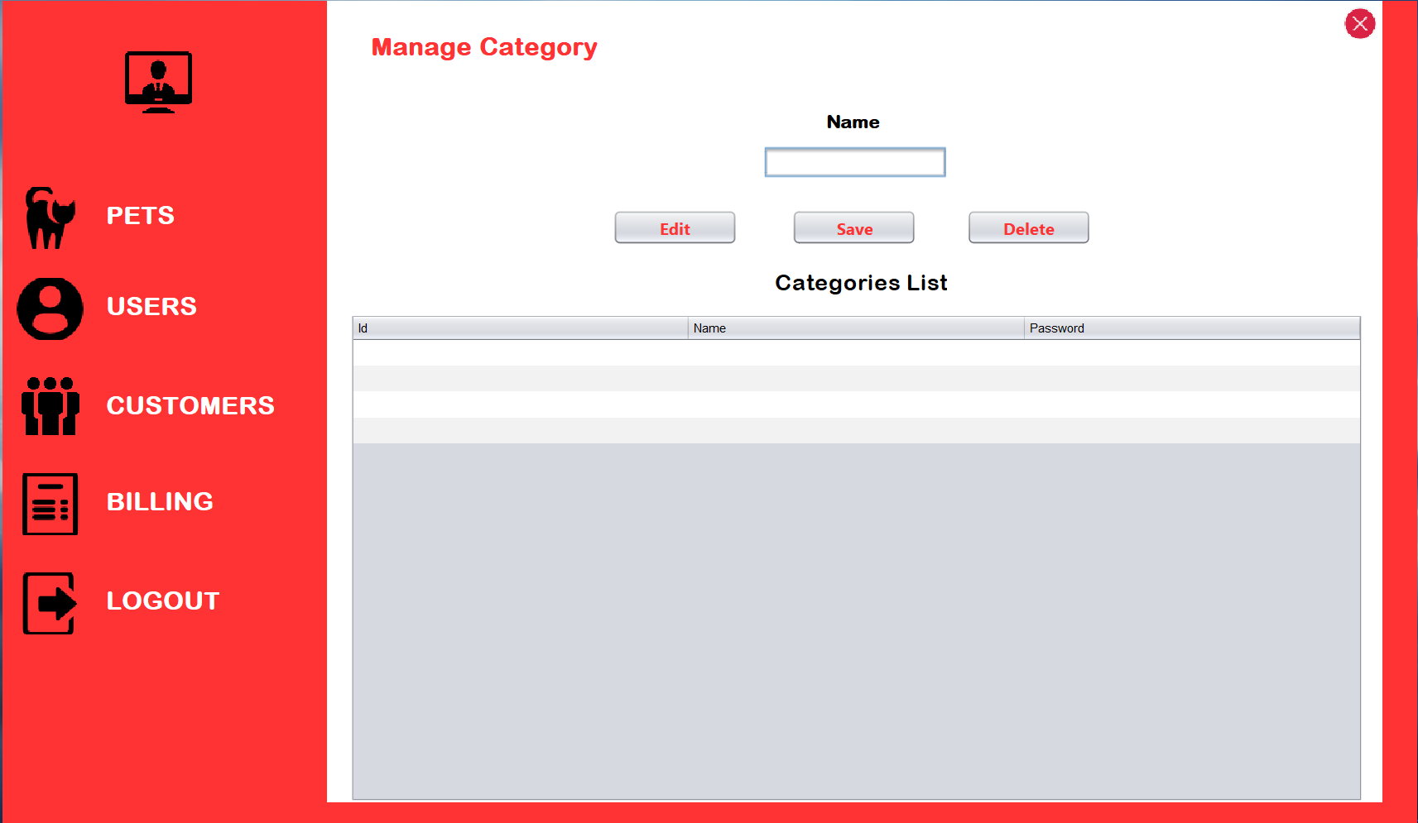

Fig 13: Category Page

7

. Customer Page

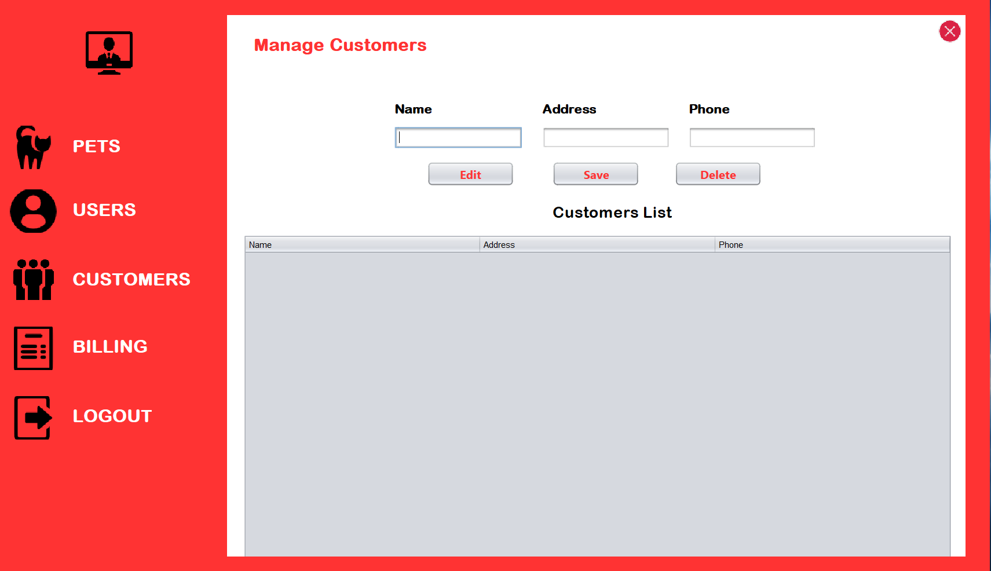

Fig 14: Customer Page

8

. Billing Page

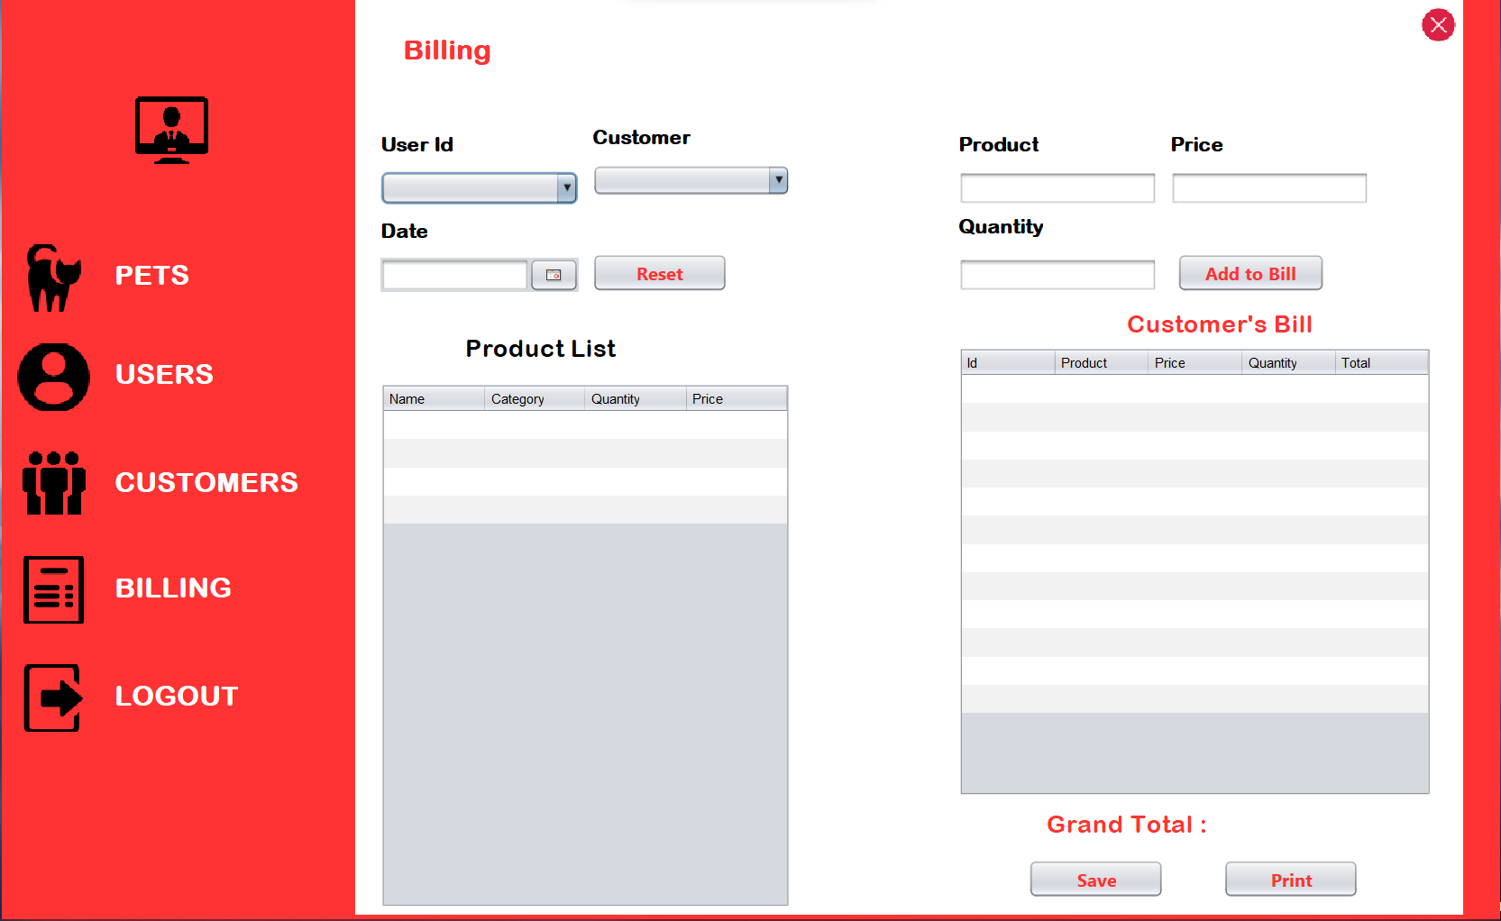

Fig 15: Billing Page

### 4.4 Test Cases

**Employee Login:**

|  |  |  |  |  |
| --- | --- | --- | --- | --- |
| **Sr. No.** | **Possible Inputs** | **Expected Result** | **Actual Result** | **Result (pass/fail)** |
| **1** | Valid Username and correct Password | Login Success Message and Redirect to dashboard | Login Success  Message and  Redirect to dashboard | Pass |
| **2** | Valid Username and incorrect Password | Login Failure Message and Reload login Page | Login Failure  Message and Reload login Page | Pass |
| **3** | Invalid Username and correct  Password | Login Failure Message and Reload login Page | Login Failure  Message and Reload login Page | Pass |
| **4** | Invalid Username and incorrect  Password | Login Failure Message and Reload login Page | Login Failure  Message and Reload login Page | Pass |
| **5** | Click on Admin | Redirect to Admin Login page | Redirect to Admin Login page | Pass |

**Admin Login:**

|  |  |  |  |  |
| --- | --- | --- | --- | --- |
| **Sr. No.** | **Possible Inputs** | **Expected Result** | **Actual Result** | **Result (pass/fail)** |
| **1** | Valid Password | Login Success  and  Redirect to main dashboard | Login Success  and  Redirect to main dashboard | Pass |
| **2** | Invalid Password | Login Failure Message | Login Failure Message | Pass |

**Pet :**

|  |  |  |  |  |
| --- | --- | --- | --- | --- |
| **Sr. No.** | **Possible Inputs** | **Expected Result** | **Actual Result** | **Result (pass/fail)** |
| **1** | Enter pet name, category, quantity,priceand click on save button | Pet added successfully | Pet added successfully | Pass |
| **2** | Enter pet data for update - name, category, quantity,priceand click on edit button | Pet updated successfully | Pet added successfully | Pass |

## CONCLUSION

In conclusion, the development of the Pet Shop Management System signifies a significant advancement in optimizing the operations of pet shops through streamlined digital solutions. By offering a user-friendly interface, robust backend functionalities, and seamless integration of various features, the system enhances the overall management of pet-related activities. The incorporation of modules such as Pets Management, Customer Management, and Billing ensures a comprehensive and efficient approach to handling diverse tasks within a pet shop.

With features like real-time data tracking, secure user authentication, and a responsive system, the Pet Shop Management System ensures a positive and reliable experience for both pet shop owners and customers. As the pet industry evolves, this standalone Java application is poised to play a crucial role in reshaping how pet shops operate, fostering a more organized and customer-centric environment. The success of this project not only signifies a technological milestone but also reflects a commitment to advancing the future of pet shop management and providing a seamless experience for all stakeholders involved.

## BIBLIOGRAPHY

[www.google.com](http://www.google.com/)  [www.youtube.com](http://www.youtube.com/) [www.javatpoint.com/uml-diagrams](http://www.javatpoint.com/uml-diagrams) [www.lucidchart.com/blog/types-of-UML-diagrams](http://www.lucidchart.com/blog/types-of-UML-diagrams) [https://creately.com](https://creately.com/) [www.tutorialspoint.com](http://www.tutorialspoint.com/) [https://stackoverflow.com](https://stackoverflow.com/)